Test Report and Result Document

Motorola Deep Connect

*Date: 22-05-2024*

**Owner: Morphedo Technologies Pvt Ltd**

# Test Objective:

*To test the functionality of the Bluetooth module and the 16*2 LCD screen*

**Test Summary:**

**This test will be performed to ensure that the DTMF module is working as intended. This test requires an extra walkie talkie which will be interacting with the DEEP CONNECT BOX. The Walkie talkie will be sending the DTMF tones to the box and same will be cross checked on the display.**

# Components Used:

## DEEP CONNECT BOX

Walkie Talkie

Mobile phone

Serial Bluetooth terminal app

# Test Setup:

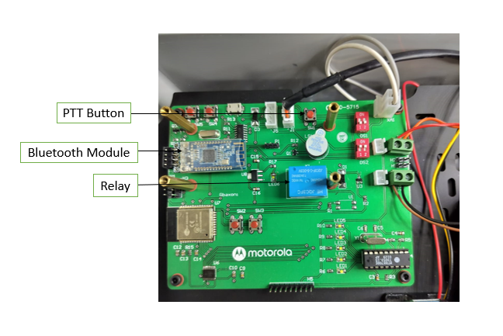

Fig 1

# Test Procedure:

# Steps:

1. 1. Power up the device by connecting the power connector to the female port and turn on all the switches in the box.

# Open the Serial Bluetooth Terminal app on your Android phone.

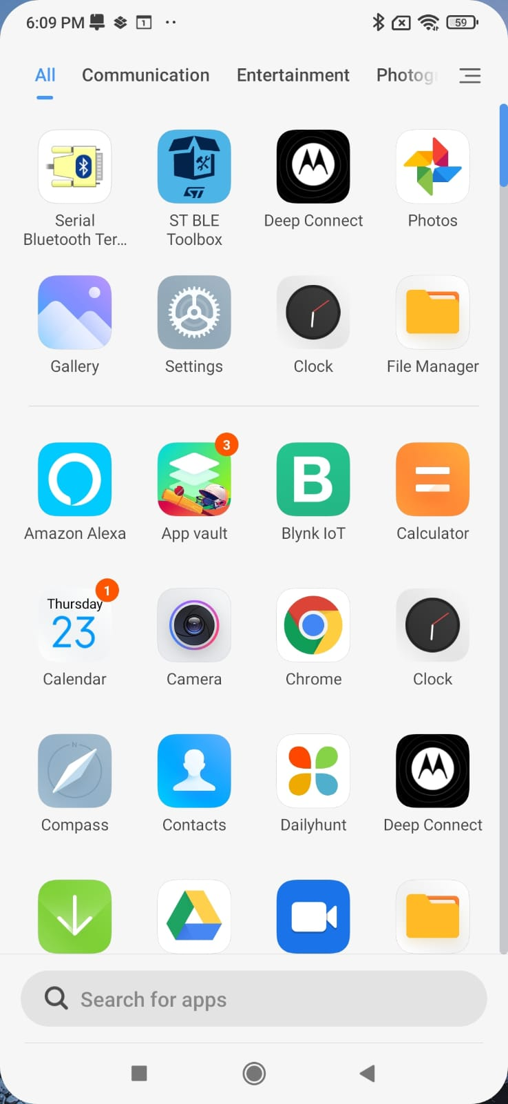

# Click on the "hamburger" menu (three horizontal lines) on the left side.



4.Select "Devices" from the menu.

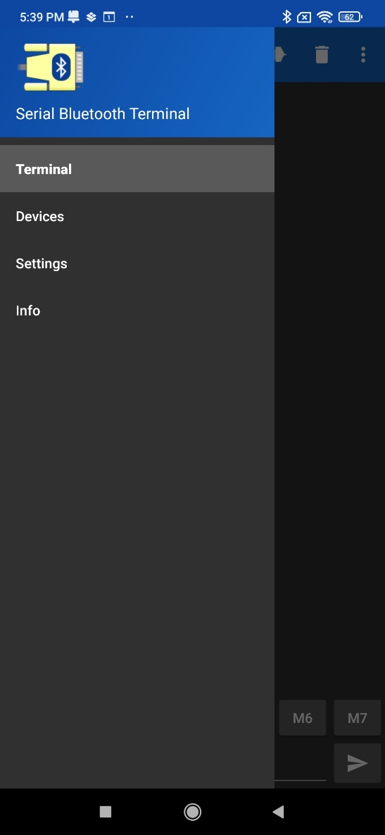

# Click on "Bluetooth LE" to search for devices.

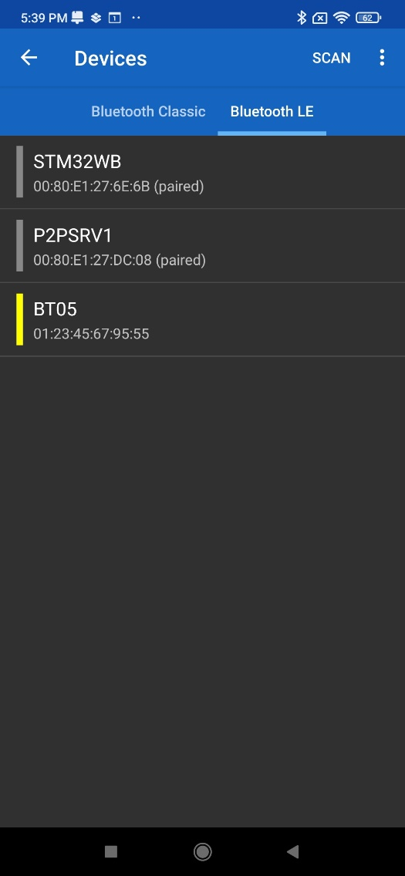 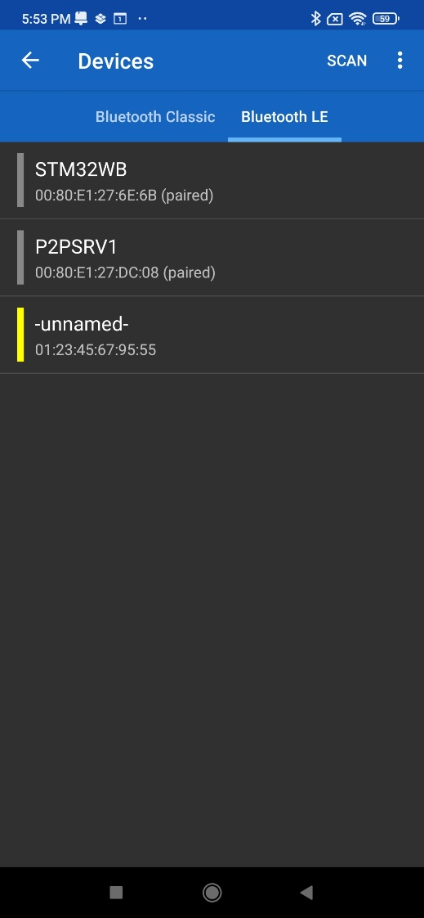

# Find and click on "BT05" to connect to the Deep Connect device. It should connect automatically.

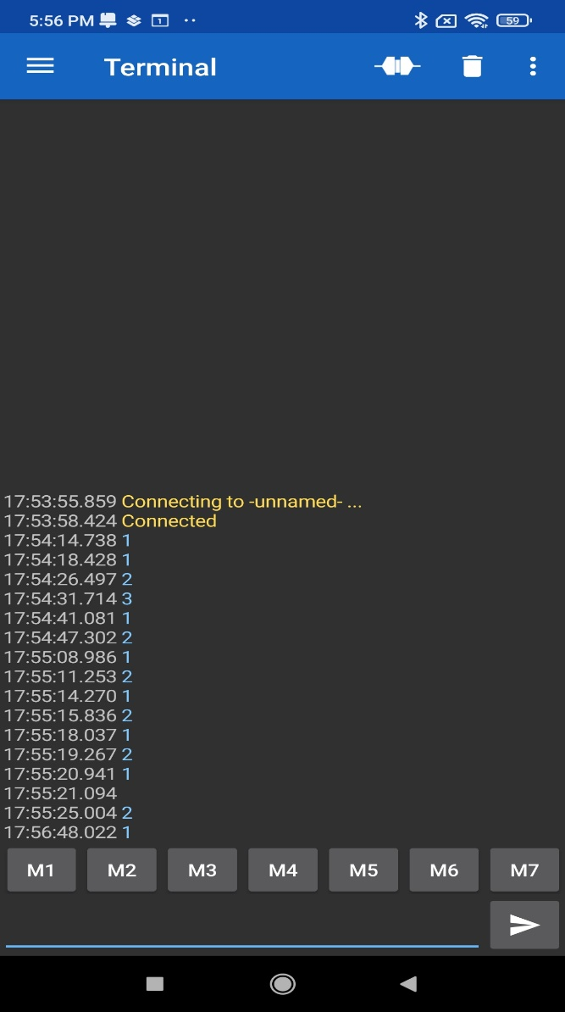

# To test the PTT (Push-to-Talk) function:

# Type 1 and press Enter. This will turn on the PTT, and the TX/RX light will turn red.

# Type 2 and press Enter. This will turn off the PTT, and the TX/RX light will turn off.

# To check the temperature/humidity sensor:

# Type 4 and press Enter. The sensor data will be displayed on the 16x2 LCD screen.

# Observation Table:

|  |  |  |
| --- | --- | --- |
| **Sno.** | **Observation** | **Output Images** |
|  | *Output when pressing 1 the PTT button is ON* and the TX/RX light will turn red |  |
|  | *Output when pressing 0* turn off the PTT, and the TX/RX light will turn off |  |
|  | *Output when pressing 2* turn off the PTT, and the TX/RX light will turn off |  |
|  | *Output when pressing 4* we get the data from temperature/Humidity sensor data will be displayed on the mobile screen |  |

# Result & Conclusion:

*As per the observations we can tell that the DTMF module is working as intended and it is giving correct responses on every key.*